**Cardiac 31P CSI: Simplified Workflow Description**

**Paweł Tokarczuk – Robert Steiner MRI Suite – December 2018**

**Introduction**

To use the MATLAB scripts efficiently, begin by collecting your studies together in a common top-level project folder as follows:

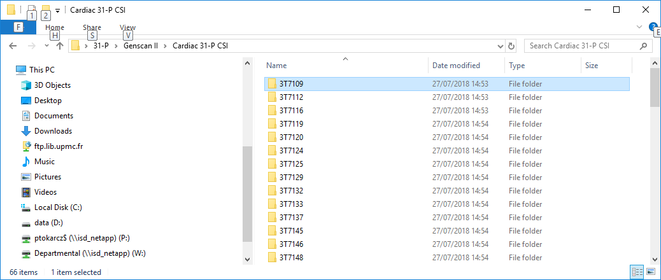

The sub-folders have the same name as the scanner ID (locally, the “3T number”), and each should contain a 4-chamber localizer and the CSI scan that you wish to analyze. Within your MATLAB workspace, you should also have an XLSX file which matches the scanner ID to the subject ID; for an anonymized subject called Alex Brown, this might be something like 14AB01234.

The workflow proceeds in 4 distinct stages, using a combination of jMRUI and MATLAB.

The top-level folder is identified in the text file:

***Top-Level Project Folder.txt***

If this does not exist, you will be prompted to create it.

1. **Initial data Visualization and Voxel Selection in jMRUI**

* Start jMRUI from the shortcut to jmruicl.bat.
* From the Wizard, select SpectrIm.
* Load the CSI dataset: File | Open Image / Spectroscopy File.

This file will be in either DCM or IMA format.

* Load the 4-chamber localizer (one thick slice, with several epochs from a triggered acquisition) at the cardiac phase corresponding to the trigger delay of the CSI scan. This should be where there is minimum cardiac motion (at end-diastole); in practice, selecting the final frame should be satisfactory, and in any case, nothing quantitative in the later analysis depends on it.

Again, use: File | Open Image / Spectroscopy File.

* Apodize the data for a better appearance:

Processing | Apodization

Select the Gaussian lineshape

Enter 15 (Hz) in the Line Broadening edit window

Apply to All.

* Auto-phase the spectra:

Processing | Auto-Phasing

Select limits of - 18 and 8 (ppm)

Apply to All.

* Using the mouse, click into the green localizing grid and try to identify a few voxels in the inter-ventricular septum (perhaps 1-4) that show good 31P spectra. Look for narrow peaks without splitting, good SNR – because the voxels will later be averaged together – and identifiable PCr and ATP peaks, at least. Note down these grid coordinates in an abbreviated form, perhaps in an open Notepad file.

Avoid voxels very close to the apex of the heart: these will probably be contaminated with signal from the muscle in the chest wall.

E.g., to select the voxels marked in jMRUI as (5/8, 3/8, 1/1) and (5/8, 4/8, 1/1), write “[5, 3] [5, 4]”.

* To make a record of the geometry of the CSI scan, take a screenshot of the jMRUI window and save it in the subject sub-folder.

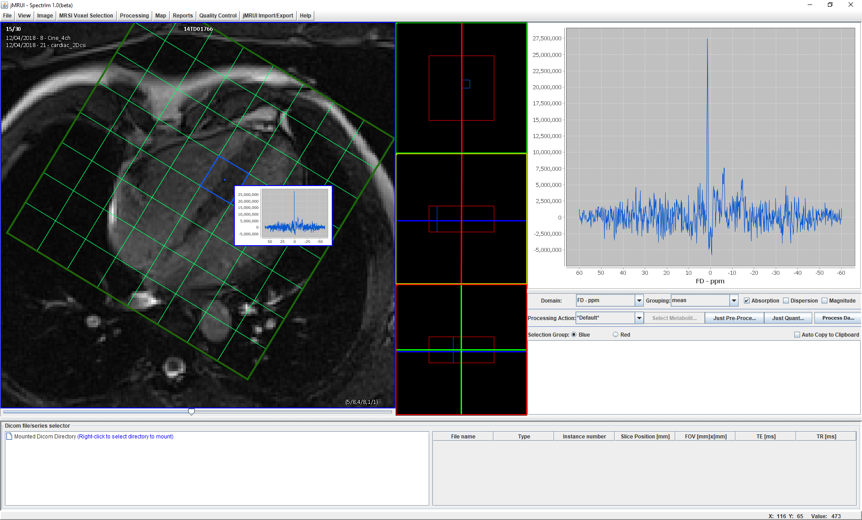

**Figure 1. Localized 31P spectra on a 1H pilot scan in jMRUI.**

1. **Data pre-processing**

* Run the MATLAB script:

***pft_PreProcessCsiData.m***

You will be prompted for a subject sub-folder, then the CSI file which you previewed in jMRUI.

You will also need to type (or copy-paste) the coordinates of your selected voxels, in the format given in step (1).

The script will perform a number of pre-processing steps on the mixed spatial-spectral data (decimation, line-broadening, zero-filling, automated phase-correction and frequency alignment) and create a number of output files, some for “auditing” and others for further analysis. Look, in particular, for a summary PDF with a name in the format:

***Scanner ID – Subject ID – Cardiac CSI Summary.pdf***

This will consist of 3 pages, as follows:

C:\Users\ptokarcz\Desktop\Refined CSI Workflow 20-12-2018\3T7109\3T7109 - 14TD01766 - CSI Matrix Plot.emf

**Figure 2.a. Spatially localized spectra after pre-processing;**

**the selected voxels are shown in red.**

**C:\Users\ptokarcz\Desktop\Refined CSI Workflow 20-12-2018\3T7109\3T7109 - 14TD01766 - Septal Spectra.emf**

**Figure 2.b. The pre-processed spectra from the selected voxels.**

**C:\Users\ptokarcz\Desktop\Refined CSI Workflow 20-12-2018\3T7109\3T7109 - 14TD01766 - Averaged Septal Spectrum.emf**

**Figure 2.c. The averaged septal spectrum.**

1. **Peak Fitting in jMRUI**

* Re-open jMRUI, and select the “1D / Time Series” button in the MRUI Wizard.

In your selected study, browse for the file:

***_31P_card_recon.txt***

You should now see an averaged spectrum such as the one in Figure 2.c.

* If the data appear as an FID, select View | Spectrum.
* If need be, set the axis to display the frequency in ppm: Options | Units in PPM.
* Now identify the PCr peak, which should be the tallest, and at approximately 1.2 ppm.
* Zoom in on the PCr peak, by dragging a box around it (from bottom-left to top-right).
* Right-click on the pinnacle of the PCr peak and select “Set zero reference”.
* Now, initialize the quantitation: **Quantitation | AMARES**
* A new dialog will appear: **Database for Starting Values**

Select the Starting Values tab: **Database | Load / Add**

Load the file:

***P31_cardAnalysis_LMS_03062018.sv***

Repeat for the Overall Phases tab, to read in the file:

***P31_cardAnalysis_LMS_03062018.op***

Finally, from the Prior Knowledge tab, read in:

***P31card_analysis_Hsmith_20181219_update.pk***

* Click “Quantify”; after some time, a Results window will appear. This is well worth a screenshot.
* Finally, save the AMARES results: **File | Save This | Save as Text**

Accept the default filename: ***Septal_31P_Spectrum.txt***

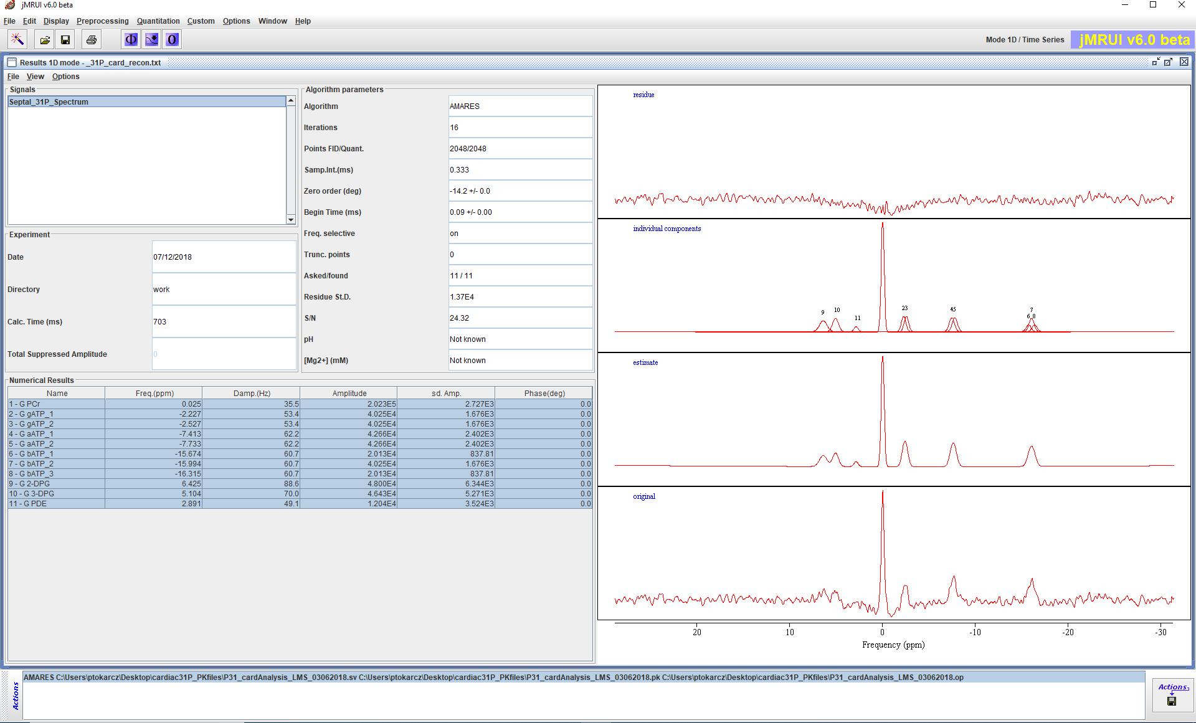

**Figure 4. The AMARES results window.**

1. **PCr:ATP Calculation in MATLAB**

* Run the script:

***pft_AnalyzeCsiData.m***

You will be prompted for a subject folder as before.

The processing is very quick – watch the MATLAB command line for a completion message.

* Look for the raw and corrected results in:

***Scanner ID – Subject ID – CARDIAC_31P_RESULTS.csv***

and

***Scanner ID – Subject ID – CARDIAC_31P_RESULTS.xlsx***

These results are also appended to a master XLSX file within the top-level folder:

***Collated Cardiac CSI Results.xlsx***

**Conclusion**

This is the full process to obtain the spectral “vital statistics” from a cardiac CSI scan. Although the workflow is broken into steps, it is not too onerous, and the whole task should only take a few minutes.

The results will become interesting at the group analysis stage (by genotype or phenotype).